Willyy1991
We're going to need:
Main2Raw
SEFStool
Both you can find in Usefull Content\Extract FS

Then go to the download section and download your firmware;
for example I will get the w810i firmware (you need to download the FS, not the MAIN!)
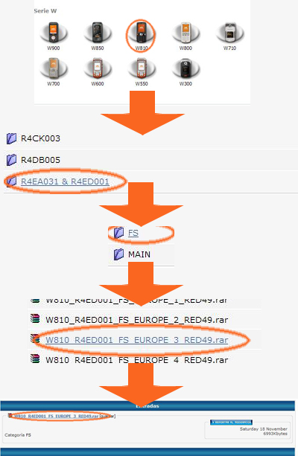
(just for those who dont know...)
Now extract the .exe's of SEFStool & Main2Raw to the same directory on your desktop (you can move them later) then open that directory and put the firmware you wish to extract in it... now you'll have:
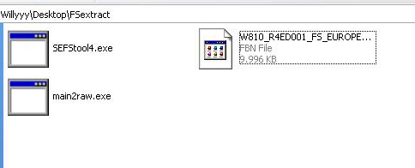
then select the FS firmware and drag it to the main2raw.exe, it will extract a file, the folder now should look like this:
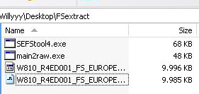
now.. i had a problem with dragging the .raw to sefstool, but if dragging the raw file to SEFStool4.exe worked you dont have to do this:
it would only give me a .FS file, not a folder... the way I did it was using the command promt. To get to the command prompt go to start>run and type cmd, once in the command prompt type this:
cd %userprofile%\Desktop\FSExtract (or the name of the folder you chose when extracting the executables)
then type sefstool4.exe <filename.raw> (e.g. "sefstool4.exe W810_R4ED001_FS_EUROPE_3_RED49.raw")
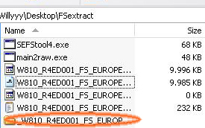
then it will get working and when its done you will have a folder called W810_R4ED001_FS_EUROPE_3_RED49 in the directory you had the .raw file, that is the file system of your phones firmware...
At final you'll have:
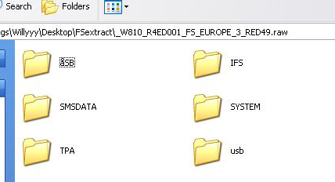
This could be handy for people who don't know where to put there files or just want to experiment with their phones...
i made this as noob as i could and described each step... ill hope it will help some out...
and i couldn't put this in the tutorial forum so if an admin would like to do it if he finds it helpful...

